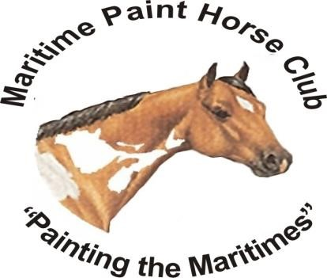
Maritime Paint Horse Club Jodi Smith
1649 Route 112
Upper Coverdale, NB E1J 1X9
506-866-8501

Dear Supporter,

The Maritime Paint Horse Club (MPHC) is a non-profit organization with members across the Maritime Provinces. Our club was established in 1994 and has been hosting horse events for the last 28 years, even achieving a Gold Star of Distinction from the American Paint Horse Association for 2018. We strive to put on horse events that are exhibitor/family friendly and promote interest in the horse industry. Each year we seek sponsorships to help facilitate our events and we would like to ask for your support in a sponsorship for this year’s horse show.

We have four levels of sponsorship to choose from:

Platinum – We will display a banner (if provided by the sponsor) at the show and place your name/logo and website link on the front page of our website. Cost $500 - $1,000.

Gold – Your name/logo and website link will be placed on the front page of our website. Cost $250 - $499.

Silver - Your name/logo and website link will be placed on our website sponsor page. Cost $100 - $249.

Bronze – Your name/logo and website link will be placed on our website sponsor page. Cost $99 & under.

In return for your sponsorship, your name/logo/website link will be placed on our website (www.maritimepainthorse.com) as well as promoted in social media on our Facebook group page which has over 1,300 members. Additionally, MPHC will announce your name several times during our show and it will be listed on posters displayed at the show facilities. We also give out exhibitor swag bags to participants and we would love to include any brochures or other promotional materials from you. We are striving for 100 exhibitors this year; if you decide you would like to include something in our exhibitor swag bags, we would request a total of 100 items.

If you are interested in this unique opportunity, or have further questions, please do not hesitate to call 506-866-8501 or email at maritimepainthorseclub@hotmail.com.

Your time and consideration are greatly appreciated!

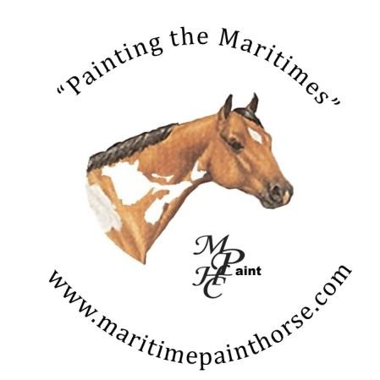

Sponsor Information Sheet

Name: _____________________________________________________________________________

Phone: ____________________________Company: _______________________________________

Company Phone: _____________________________Date: __________________________________

Address: ___________________________________________________________________________

City: _______________________________________ Province: ______________________________

Postal Code: _________________________________

E-mail: ____________________________________________________________________________

Method of Payment (please circle one): Cheque Cash E-Transfer

Amount: ___________________

Class Requested to Sponsor: __________________________________________________________

Best method of contact: ______________________________________________________________

Receipt (please circle one): Mailed E-mailed

Thank you for your support!

Maritime Paint Horse Club
Jodi Smith
1649 Route 112
Upper Coverdale, NB
E1J 1X9
506-866-8501
maritimepainthorseclub@hotmail.com

